# **The 7 Best Essential Oils for Hair Growth & More**

When it comes to using essential oils for hair, there are plenty of beneficial choices. Whether you are looking to [thicken your hair](https://draxe.com/beauty/how-to-thicken-hair/), treat dandruff and dry scalp, give your hair strength and shine, or lighten your hair naturally, essential oils are much safer and just as effective as conventional hair care products.

They are also more cost-effective — one bottle of your favorite essential oil can not only nourish your hair, but it can help reduce stress, alleviate pain and fight skin infections as well. Plus, essential oils are all-natural, which means they are free of dangerous chemicals and better for the environment and your home, too.

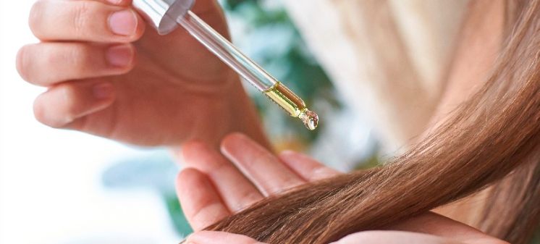

#### Lavender

Lavender oil has antimicrobial properties, and it can be used to combat bacterial and fungal disorders. Some other [lavender oil benefits](https://draxe.com/essential-oils/lavender-oil-benefits/) are its ability to soothe the scalp and treat dry skin and hair. Plus, because emotional stress is a factor that can contribute to thinning hair, lavender oil can be used to create a tranquil and stress-free environment.

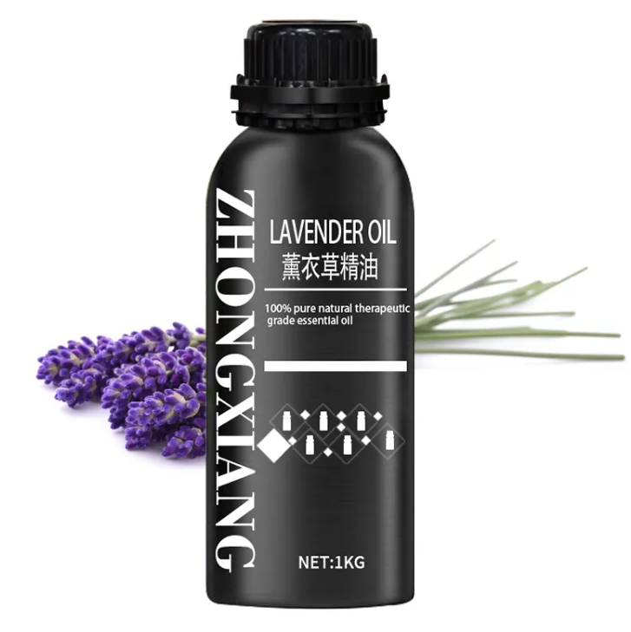

#### 2. Rosemary

Rosemary oil is one of the top essential oils for hair thickness and growth. It is used to increase cellular metabolism, which stimulates hair growth and promotes healing。

When it comes to boosting your hair health, the [benefits of rosemary oil](https://draxe.com/essential-oils/rosemary-oil-uses-benefits/) also include preventing baldness, slowing the graying process, and treating dandruff and dry scalp.

To use rosemary oil for your hair, mix it with olive oil and lavender oil ([olive oil hair treatment with rosemary and lavender](https://draxe.com/beauty/olive-oil-hair-treatment/)), and then massage the mixture into your scalp for about two minutes. Leave it in your hair for three to four hours, and then wash your hair as usual.

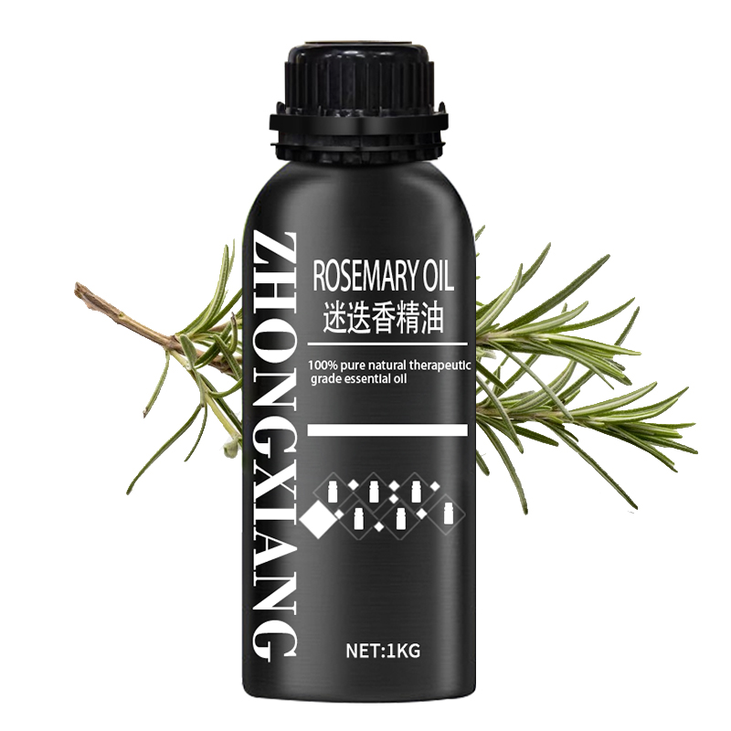

#### 3. Chamomile

[Chamomile oil](https://draxe.com/essential-oils/roman-chamomile-essential-oil/) is a great essential oil for hair because it adds shine and softness to your hair while soothing your scalp.

Did you know that chamomile essential oil can be used to [lighten your hair naturally](https://draxe.com/beauty/how-to-lighten-hair-naturally/)?

Combine five drops of chamomile essential oil with a tablespoon of sea salt and one-third cup of baking soda. Use warm water to create a paste, and apply the mixture to your hair. Massage it into your scalp and at the base of your hair, then allow it to sit for about half an hour before rinsing it out.

If you want a bolder affect, keep the paste on as you sit in the sun.

Research suggests that 50 percent of women dye their hair regularly and feel more attractive right after having their hair dyed, but conventional hair products that are used to lighten hair [contain](https://www.ncbi.nlm.nih.gov/pmc/articles/PMC3927172/" \t "https://draxe.com/essential-oils/essential-oils-for-hair/_blank) dangerous chemicals that can cause numerous health risks. Choosing a natural alternative ensures that you aren’t exposed to unhealthy hair-dyeing products, like

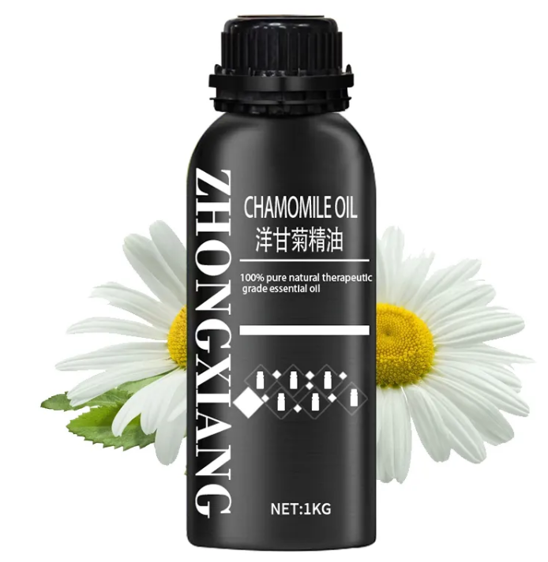

**Jian Zhongxiang Natural Plants Co.,Ltd**

**Mobile:+86-13125261380**

**Whatsapp: +8613125261380**

**e-mail: [zx-joy@jxzxbt.com](mailto:zx-joy@jxzxbt.com)**

**Wechat: +8613125261380**